Hello, my name is Viet NGUYEN, here's my script presentation of my STN English A2 podcast.

Right now, I studied License 1 Informatique at the University of Paris 8. Today I want to talk about the reasons that I chose this Informatique industry. Honestly, choosing a major to study for is often essential to deciding what you will do in the future.

Initially, I chose to study Informatique only because it was known as a light, high-paying job and only needed to have a computer to do and learn.

However, after a period of research and learning, I feel that this is the way to develop many fields in the future: medicine, design, cultivation, communication, ...

And even, I also believe that the development of IT in the future will bring people closer to what seemed only in sci-fi movies.

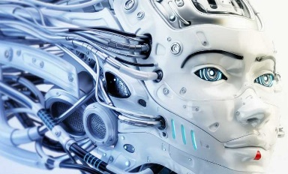

At the forefront of those strides, robots, Artificial intelligence(AI), Internet of Things(IoT), ... The use of AI has become more popular on applications and websites. And for robots too, it's not uncommon for me to find information about an advanced discipline of Informatique that is robotique.

As you know, what we imagine about science and technology is often associated with the image of robots.

The branch of technology that deals with the design, construction, operation, and application of robots, as well as computer systems for their control, sensory feedback, and information processing is robotics. These technologies deal with automated machines that can take the place of humans in dangerous environments or manufacturing processes, or resemble humans in appearance, behavior, or cognition. Many of today's robots are inspired by nature contributing to the field of bio-inspired robotics.

From there, gradually expanding the diversity of robots with mini robots like ants and bugs to moving robots that can communicate like a human. It even includes many different categories, for example:

At the most recent time at the University of Vermont (USA) has made a step forward in the invention of Living robots (xenobots), which is that the robot at the cell level is expected to help people do things micro.

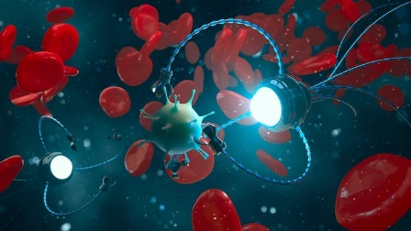 *Well, that's good news in dealing with Covid-19, right?*

Although they are not completely mechanical like other robots, it is possible to program them.

So, a robot is a definition of something that can operate automatically according to the original design and setup, or that can also be operated by being controlled. It is by no means limited to the word 'machine'.

Anyway, all I want are just a few small discoveries in IT like knowing new inventions. It really got me interested in finding out what I was after. Well, here is the end, thanks for listening, I hope you have a good day.